Day 24 - 08th Aug 2025

Abstract Factory Design pattern

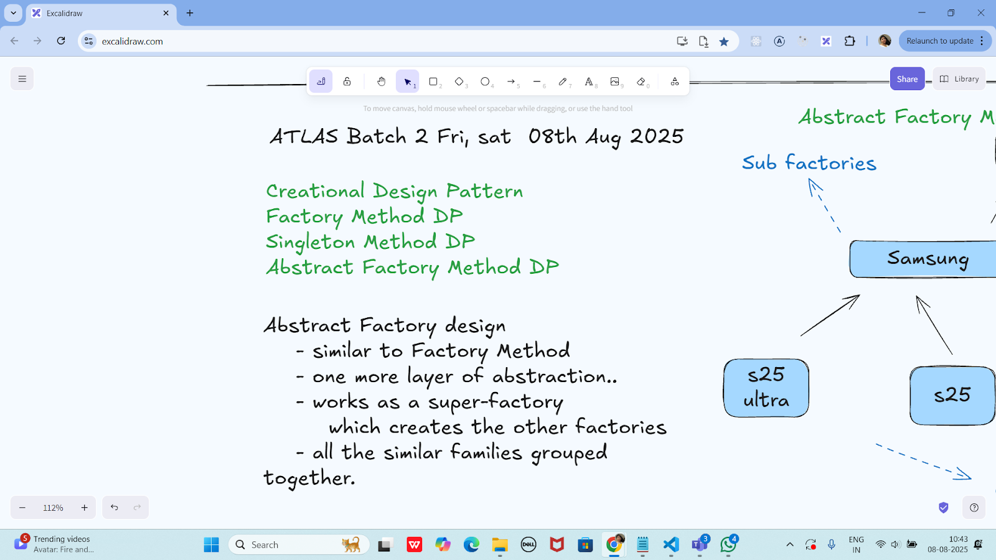

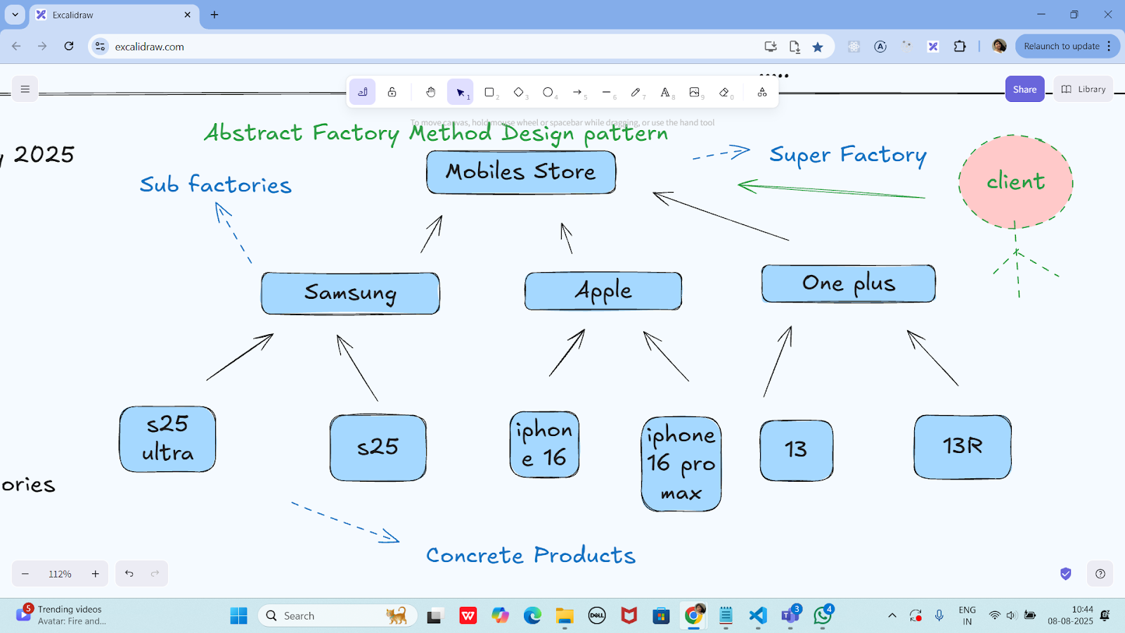

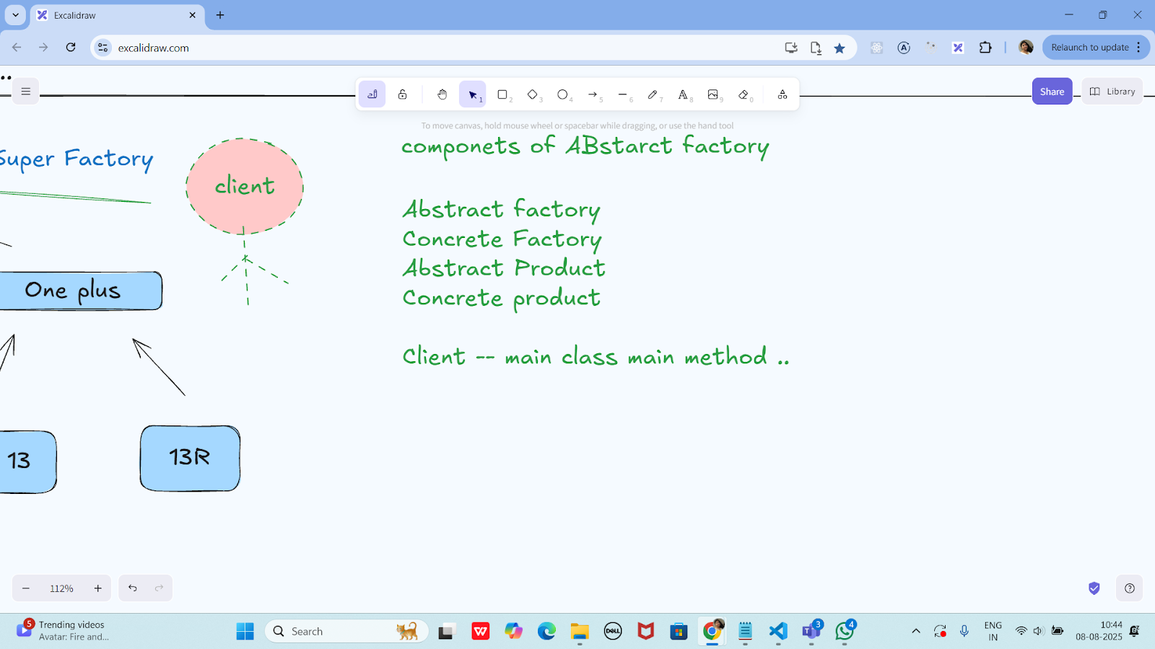

Task 01:

package Demo_Codes.Module_03_OOAD.AbstractFactoryDP.AbstractFactoryDpPack;

import java.util.Objects;

public class Apple {

private Apple() {

// Prevent instantiation

}

public static Mobile getMobile(String model) {

if (Objects.*equals*(model, "iphone16")) {

return new Mobile("Here is your iPhone 16");

} else if (Objects.*equals*(model, "iphone16MaxPro")) {

return new Mobile("Here is your iPhone 16 Max Pro");

}

return new NoMobile();

}

}

package Demo_Codes.Module_03_OOAD.AbstractFactoryDP.AbstractFactoryDpPack;

public class ClientAbstractFactory {

public static void main(String[] args) {

Mobile mObj = MobileStore.*getMobile*("Apple", "iphone16");

mObj.getDesc();

System.*out*.println("...");

}

}

package Demo_Codes.Module_03_OOAD.AbstractFactoryDP.AbstractFactoryDpPack;

public class Mobile {

String desc;

public Mobile(String model) {

this.desc = model;

}

public void getDesc() {

System.*out*.println(this.desc);

}

}

package Demo_Codes.Module_03_OOAD.AbstractFactoryDP.AbstractFactoryDpPack;

import java.util.Objects;

public class MobileStore {

private MobileStore() {

System.*out*.println("Hello, welcome to the world of Mobile");

}

public static Mobile getMobile(String brand, String model) {

if (Objects.*equals*(brand, "Apple")) {

System.*out*.println("Here are your Apple Models");

return Apple.*getMobile*(model);

}

// else if (Objects.equals(brand, "Samsung")) {

// System.out.println("Here are your Samsung Models");

// return Samsung.getMobile(model);

// }

return new NoMobile();

}

}

package Demo_Codes.Module_03_OOAD.AbstractFactoryDP.AbstractFactoryDpPack;

public class NoMobile extends Mobile {

public NoMobile() {

super("Sorry, invalid model");

}

}

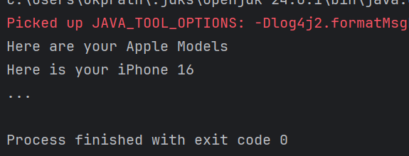

Hometask01

Adding samsung and oneplus in task 1

package hometask;

import java.util.Objects;

public class Apple {

private Apple() {

// Prevent instantiation

}

public static Mobile getMobile(String model) {

if (Objects.*equals*(model, "iphone16")) {

return new Mobile("Here is your iPhone 16");

} else if (Objects.*equals*(model, "iphone16MaxPro")) {

return new Mobile("Here is your iPhone 16 Max Pro");

}

return new NoMobile();

}

}

package hometask;

public class Mobile {

String desc;

public Mobile(String model) {

this.desc = model;

}

public void getDesc() {

System.*out*.println(this.desc);

}

}

package hometask;

import java.util.Objects;

public class MobileStore {

private MobileStore() {

System.*out*.println("Hello, welcome to the world of Mobile");

}

public static Mobile getMobile(String brand, String model) {

if (Objects.*equals*(brand, "Apple")) {

System.*out*.println("Here are your Apple Models");

return Apple.*getMobile*(model);

} else if (Objects.*equals*(brand, "Samsung")) {

System.*out*.println("Here are your Samsung Models");

return Samsung.*getMobile*(model);

} else if (Objects.*equals*(brand, "OnePlus")) {

System.*out*.println("Here are your OnePlus Models");

return OnePlus.*getMobile*(model);

}

return new NoMobile();

}

}

package hometask;

public class NoMobile extends Mobile {

public NoMobile() {

super("Sorry, invalid model");

}

}

package hometask;

import java.util.Objects; // ✅ add this

public class OnePlus {

private OnePlus() {

// Prevent instantiation

}

public static Mobile getMobile(String model) {

if (Objects.*equals*(model, "OnePlus12")) {

return new Mobile("Here is your OnePlus 12");

} else if (Objects.*equals*(model, "OnePlus12R")) {

return new Mobile("Here is your OnePlus 12R");

}

return new NoMobile();

}

}

package hometask;

import java.util.Objects;

public class Samsung {

private Samsung() {

// Prevent instantiation

}

public static Mobile getMobile(String model) {

if (Objects.*equals*(model, "S24")) {

return new Mobile("Here is your Samsung S24");

} else if (Objects.*equals*(model, "S24Ultra")) {

return new Mobile("Here is your Samsung S24 Ultra");

}

return new NoMobile();

}

}

package hometask;

public class ClientAbstractFactory {

public static void main(String[] args) {

Mobile m1 = MobileStore.*getMobile*("Apple", "iphone16");

m1.getDesc();

Mobile m2 = MobileStore.*getMobile*("Samsung", "S24");

m2.getDesc();

Mobile m3 = MobileStore.*getMobile*("OnePlus", "OnePlus12");

m3.getDesc();

Mobile m4 = MobileStore.*getMobile*("Apple", "iphone20"); // invalid

m4.getDesc();

}

}

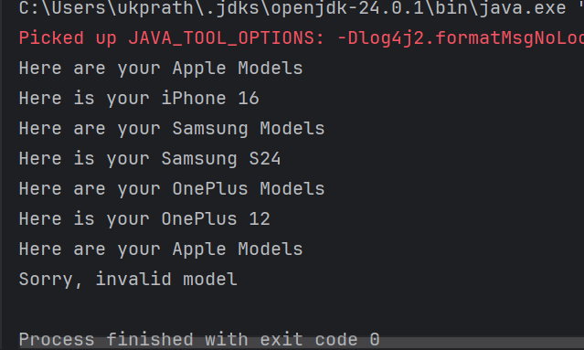

**Builder method Design pattern**

**Task 02:**

package Task02.BuilderDesignPattern;

class Laptop {

private int memory;

private int storage;

// Could add: graphicCard, processor, etc.

public Laptop() {

// Default constructor

}

// Getters and Setters

public int getMemory() {

return memory;

}

public void setMemory(int memory) {

this.memory = memory;

}

public int getStorage() {

return storage;

}

public void setStorage(int storage) {

this.storage = storage;

}

@Override

public String toString() {

return "Laptop{" +

"memory=" + memory +

"GB, storage=" + storage +

"GB}";

}

}

package Task02.BuilderDesignPattern;

interface LaptopBuilder {

LaptopBuilder buildMemory(int memory);

LaptopBuilder buildStorage(int storage);

Laptop build();

}

package Task02.BuilderDesignPattern;

class LaptopConcreteBuilder implements LaptopBuilder {

private Laptop laptop;

public LaptopConcreteBuilder() {

this.laptop = new Laptop();

}

@Override

public LaptopBuilder buildMemory(int memory) {

laptop.setMemory(memory);

return this;

}

@Override

public LaptopBuilder buildStorage(int storage) {

laptop.setStorage(storage);

return this;

}

@Override

public Laptop build() {

return laptop;

}

}

package Task02.BuilderDesignPattern;

class LaptopDirector {

private LaptopBuilder laptopBuilder;

public LaptopDirector(LaptopBuilder laptopBuilder) {

this.laptopBuilder = laptopBuilder;

}

public Laptop constructLaptop() {

return laptopBuilder

.buildMemory(16) // Example: 16GB RAM

.buildStorage(512) // Example: 512GB SSD

.build();

}

}

package Task02.BuilderDesignPattern;

public class ClientBuildMethodDP {

public static void main(String[] args) {

LaptopBuilder lbobj = new LaptopConcreteBuilder();

LaptopDirector dir = new LaptopDirector(lbobj);

Laptop lobj = dir.constructLaptop();

System.*out*.println(lobj);

}

}

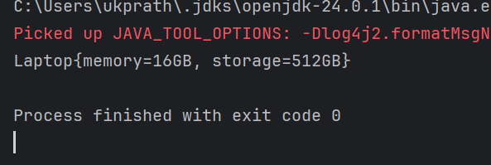

Task 03:

package Task03;

public interface Colors {

Colors clone();

String getName();

void setName(String name);

}

package Task03;

public class BlackConcretePrototype implements Colors {

private String name;

public BlackConcretePrototype() {

System.*out*.println("BlackConcretePrototype constructor is called");

}

public BlackConcretePrototype(String name) {

this.name = name;

}

@Override

public Colors clone() {

return new BlackConcretePrototype(this.name);

}

@Override

public String getName() {

return name;

}

@Override

public void setName(String name) {

this.name = name;

}

}

package Task03;

public class WhiteConcretePrototype implements Colors {

private String name;

public WhiteConcretePrototype() {

System.*out*.println("WhiteConcretePrototype constructor is called");

}

public WhiteConcretePrototype(String name) {

this.name = name;

}

@Override

public Colors clone() {

return new WhiteConcretePrototype(this.name);

}

@Override

public String getName() {

return name;

}

@Override

public void setName(String name) {

this.name = name;

}

}

package Task03;

public class Main {

public static void main(String[] args) {

Colors blackPrototypeObj = new BlackConcretePrototype("Black Color");

Colors whitePrototypeObj = new WhiteConcretePrototype("White Color");

Colors clonedBlackObj = blackPrototypeObj.clone();

Colors clonedWhiteObj = whitePrototypeObj.clone();

clonedBlackObj.setName("Dark Color");

clonedWhiteObj.setName("Light Color");

System.*out*.println("Black color is: " + clonedBlackObj.getName());

System.*out*.println("White color is: " + clonedWhiteObj.getName());

}

}

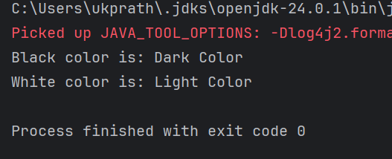

Prototype Method Design pattern

prototype interface -- Colors

Concrete prototype --- class

WhiteConcretePrototype

constructor()

constructor(String...)

clone()

BlackConcreteprototype

client code

Home tasks 01

Develop the below prototype method DP..

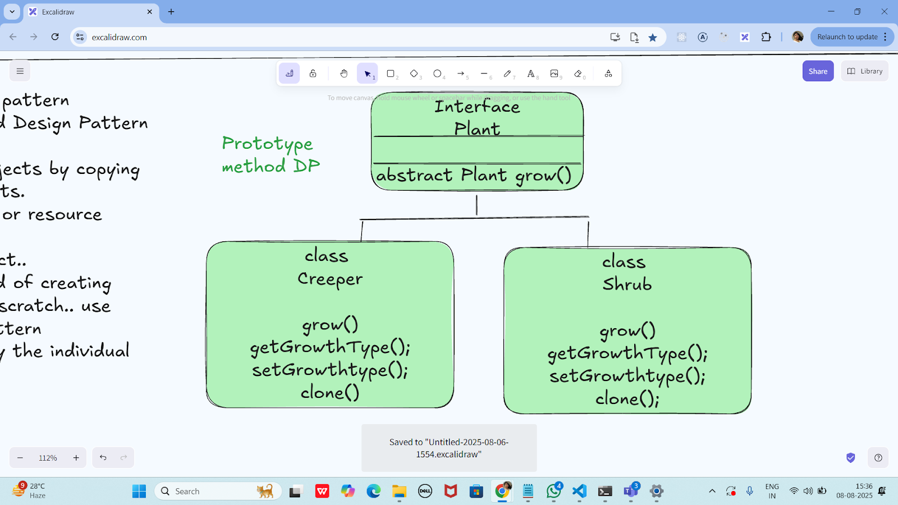

package prototype_Home_task;

public interface Plant extends Cloneable {

Plant grow();

String getGrowthType();

void setGrowthType(String growthType);

Plant clone();

}

package prototype_Home_task;

public class Creeper implements Plant {

private String growthType;

public Creeper() {

System.*out*.println("Creeper constructor is called");

}

public Creeper(String growthType) {

this.growthType = growthType;

}

@Override

public Plant grow() {

System.*out*.println("Creeper grows by spreading on the ground or climbing.");

return this;

}

@Override

public String getGrowthType() {

return growthType;

}

@Override

public void setGrowthType(String growthType) {

this.growthType = growthType;

}

@Override

public Plant clone() {

return new Creeper(this.growthType);

}

}

package prototype_Home_task;

public class Shrub implements Plant {

private String growthType;

public Shrub() {

System.*out*.println("Shrub constructor is called");

}

public Shrub(String growthType) {

this.growthType = growthType;

}

@Override

public Plant grow() {

System.*out*.println("Shrub grows as a small to medium-sized woody plant.");

return this;

}

@Override

public String getGrowthType() {

return growthType;

}

@Override

public void setGrowthType(String growthType) {

this.growthType = growthType;

}

@Override

public Plant clone() {

return new Shrub(this.growthType);

}

}

package prototype_Home_task;

public class Main {

public static void main(String[] args) {

// Original prototypes

Plant creeperPrototype = new Creeper("Climbing Plant");

Plant shrubPrototype = new Shrub("Bushy Plant");

// Cloning from prototypes

Plant clonedCreeper = creeperPrototype.clone();

Plant clonedShrub = shrubPrototype.clone();

// Changing clone names to prove independence

clonedCreeper.setGrowthType("Ground Spreader");

clonedShrub.setGrowthType("Flowering Shrub");

// Showing original and clone info

System.*out*.println("\nOriginal Creeper: " + creeperPrototype.getGrowthType());

System.*out*.println("Cloned Creeper: " + clonedCreeper.getGrowthType());

System.*out*.println("\nOriginal Shrub: " + shrubPrototype.getGrowthType());

System.*out*.println("Cloned Shrub: " + clonedShrub.getGrowthType());

// Growth actions

clonedCreeper.grow();

clonedShrub.grow();

}

}

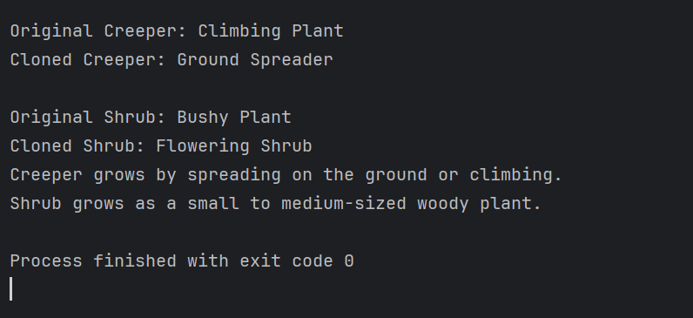

Task 04 Adaptor Design pattern

package Task04_Adapter_Design;

public class DellLaptop {

private ILaptopTarget powerSource;

public DellLaptop(ILaptopTarget powerSource) {

this.powerSource = powerSource;

}

public void charge() {

powerSource.charge();

}

public void removeCharge() {

powerSource.removeCharge();

}

}

package Task04_Adapter_Design;

public class ChargerAdaptee implements IChargerAdaptee {

public ChargerAdaptee() {}

@Override

public void charge() {

System.*out*.println("Charging my laptop");

}

@Override

public void removeCharge() {

System.*out*.println("Not charging my laptop");

}

}

package Task04_Adapter_Design;

public interface IChargerAdaptee {

void charge();

void removeCharge();

}

package Task04_Adapter_Design;

public interface ILaptopTarget {

void charge();

void removeCharge();

}

package Task04_Adapter_Design;

public class PowerSocketAdapter implements ILaptopTarget {

private IChargerAdaptee charger;

public PowerSocketAdapter(IChargerAdaptee charger) {

this.charger = charger;

}

@Override

public void charge() {

charger.charge();

}

@Override

public void removeCharge() {

charger.removeCharge();

}

}

package Task04_Adapter_Design;

public class Main {

public static void main(String[] args) {

System.*out*.println("Adapter Method Design Pattern");

IChargerAdaptee charger = new ChargerAdaptee();

ILaptopTarget adapter = new PowerSocketAdapter(charger);

DellLaptop dell = new DellLaptop(adapter);

dell.charge();

dell.removeCharge();

}

}

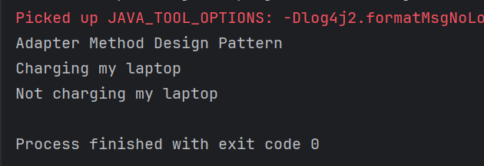

Info Box

Excalidraw updated at 10.43

<https://excalidraw.com/#json=PfNv_D1GXzAH0yPsXLqss,ab_5Dl0GZWRrpJtLtyHOVg>

Code for reference

<https://drive.google.com/drive/folders/1LwhNov1s1-vHzF9GPAObLSnP9kAvipmw?usp=sharing>